**Azad Kashmir:**

Toli Pir

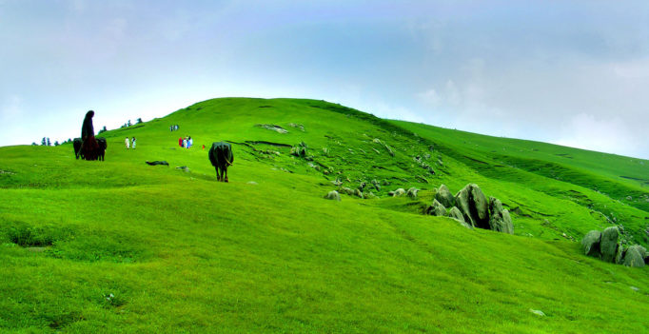

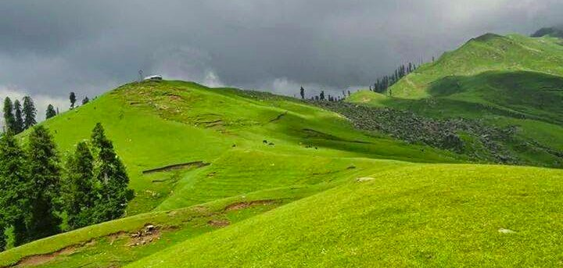

**Tolipir**‎ also spelled Tolipeer, Tauli Pir, Tooli Pir, Toli Pir, or Toli Peer) is a hilltop area situated in Tehsil Rawalakot in the Poonch District of Azad Kashmir. Its approximate elevation is about 8800ft above sea level. It is about 30km, or a 120-minute drive, from Rawalakot in Azad Kashmir. Abbaspur, Bagh and Poonch River can be viewed from Toli Pir.